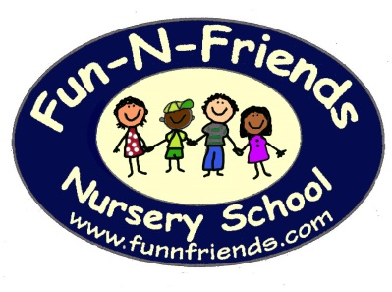
Security system fingerprint entry
Honeywell instant alert notification system
Fenced in playground

Music class bi-weekly
Serving the Community for over 30 Years!
Handwriting without tears
Sounds in Motion
Computer Labs to reinforce daily lessons and develop computer skills
Introduction to Spanish (alternating weeks with computers)
Parent/teacher conferences

Specials
Ocean Week Halloween Trick-or-Trunk
Thanksgiving Feast and Program Christmas Program
Snowmen, Snowmen Everywhere Sports Day
PJ Day Space Week
Dad’s Night (senior classes) Book Fair
Zoo Day Junior class Sing a-long
Mother Gooses Party with Moms Garden
Garden Party with Moms Space Week
St Jude Trike-a-Thon Family Fun Night
Graduation (Senior classes)

Special Visitors Special Trips
Sea Critters (senior classes) Pumpkin Picking Farm Trip
Flanders Fire Dept. Planetarium Trip (senior classes) Dentist Land of Make Believe (Seniors)
Unique Creatures

Extra Programs
Cooking With Friends Extended Day Program Date Night for Parents

Fun-N-Friends Nursery School
973-584-0365 58 Drakesdale Road Flanders, NJ 07836
www.funnfriends.com “Like” us on Facebook at Fun-N-Friends Nursery School

